



MICROSOFT ARCHITECTURE BEST PRACTICE FOR SECURITY
USECASE: SECURE HYBRID MESSAGING INFRASTRUCTURE — MOBILE ACCESS

Document Title | Microsoft Cloud Center of Excellence Overview
Presales/Technical Head | Tushar Mehrotra/Rohit Pandey
CCoE Lead | Ravishankar N
Creation Date | September 2025
Version | Description | Modified by | Date | Approved by | Date
1 | Initial Architecture design | AJEET KUMAR | 19/09/2025 | Ravi Shankar | 19/09/2025
Contents
1
1. Executive Summary 3
2. Scope and Applicability 3
3. Business Scenario Overview 3
4. Reference Architecture Overview 3
4.1 Architecture Description 3
5. Logical Architecture Components 4
5.1 Identity and Authentication Layer 4
5.2 On-Premises Messaging Layer 4
5.3 Cloud Messaging Layer 4
5.4 Secure Web Access Layer 4
5.5 Perimeter and Access Proxy Layer 4
5.6 Monitoring and Governance Controls 4
6. Cloud Center of Excellence (CCoE) Enablement Model 5
7. Conclusion 5

1. Executive Summary
This document is based on secure hybrid messaging reference architecture for mobile access. The architecture focuses on securing mobile email access (Outlook for iOS and Outlook for Android) in hybrid Microsoft Exchange environments using Microsoft Entra ID, modern authentication, and multifactor authentication (MFA).
The solution ensures that mobile users can access mailboxes hosted in Exchange Online or Exchange on-premises while maintaining strong security controls and consistent user experience.

2. Scope and Applicability
This reference architecture applies to:
- Hybrid Microsoft Exchange deployments
- Mobile messaging access scenarios
- Outlook for iOS and Outlook for Android clients
- Organizations enforcing MFA and Conditional Access
- Enterprise and CCoE-governed Microsoft 365 environments
The focus is on secure, compliant mobile messaging access.

3. Business Scenario Overview
Mobile devices introduce additional security risks, including lost devices, credential theft, and unmanaged endpoints. Organizations must secure mobile email access without blocking productivity.
This architecture addresses these challenges by combining modern authentication, Microsoft Entra Conditional Access, Intune device management, and MFA to control access to messaging services based on user and device context.

4. Reference Architecture Overview
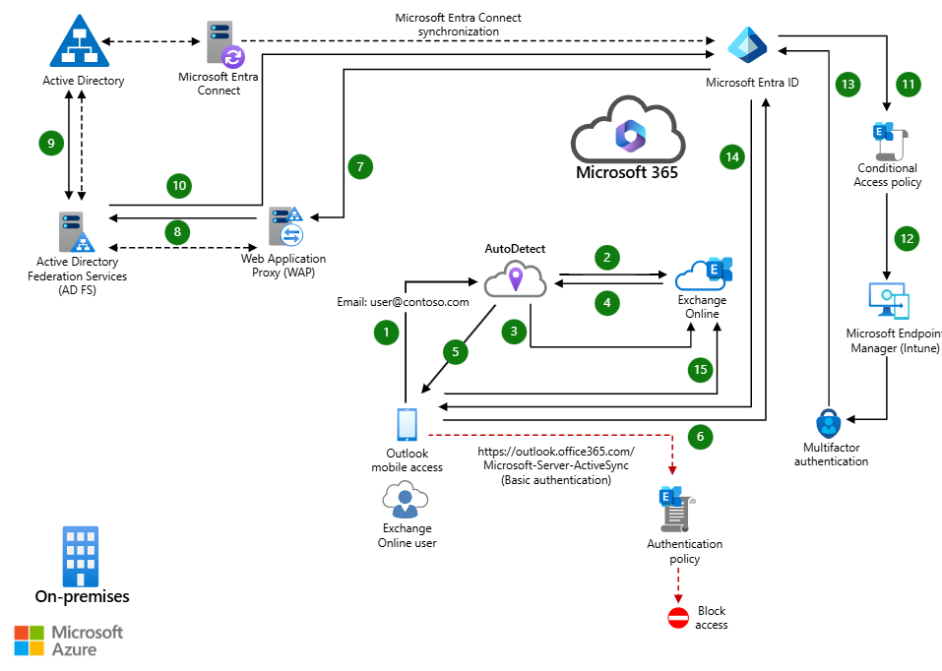
4.1 Architecture Description
The architecture supports two parallel authentication flows:
- Mobile access to Exchange Online mailboxes
- Mobile access to Exchange on-premises mailboxes in a hybrid deployment
In both scenarios, Outlook mobile uses modern authentication through Microsoft Entra ID. When domains are federated, authentication requests are securely proxied to on-premises AD FS through Web Application Proxy infrastructure.

5. Logical Architecture Components
5.1 Mobile Client Layer
- Outlook for iOS and Outlook for Android
- Support for modern authentication (OAuth 2.0)
- Secure token-based access to mailbox content
These clients are the only supported mobile apps for this architecture.

5.2 Identity and Authentication Layer
- Microsoft Entra ID for centralized authentication
- Microsoft Entra multifactor authentication (MFA)
- Optional federation using AD FS and Web Application Proxy
This layer enforces strong authentication and identity protection.

5.3 Cloud Messaging Layer (Exchange Online)
- Exchange Online mailboxes hosted in Microsoft 365
- Secure access via modern authentication tokens
- Conditional Access enforcement per user and device
Microsoft Entra ID validates access before mailbox content retrieval.

5.4 On-Premises Messaging Layer (Exchange On-Premises)
- Exchange Server deployed on-premises
- Hybrid connectivity to Microsoft Entra ID
- Secure authentication redirection through WAP and AD FS
This layer supports secure access to on-premises mailboxes from mobile devices.

5.5 Security and Device Management Layer
- Microsoft Intune for mobile device management
- Application protection policies
- Device compliance and conditional access policies
Device-based controls ensure data remains protected even on unmanaged devices.

5.6 Monitoring and Governance Controls
- Authentication and sign-in logs
- Conditional Access reporting
- Centralized security monitoring
Governance ensures visibility into mobile access patterns and security posture.

6. Cloud Center of Excellence (CCoE) Enablement Model
The CCoE uses this architecture to:
- Define approved mobile access patterns
- Enforce identity and device security standards
- Govern Conditional Access and MFA policies
7. Conclusion
The Secure Hybrid Messaging – Mobile Access Reference Architecture provides a Microsoft-aligned approach for protecting mobile access to messaging services in hybrid Exchange environments. By leveraging Microsoft Entra ID, MFA, Conditional Access, and Intune integration, organizations can secure mobile productivity without compromising user experience.

